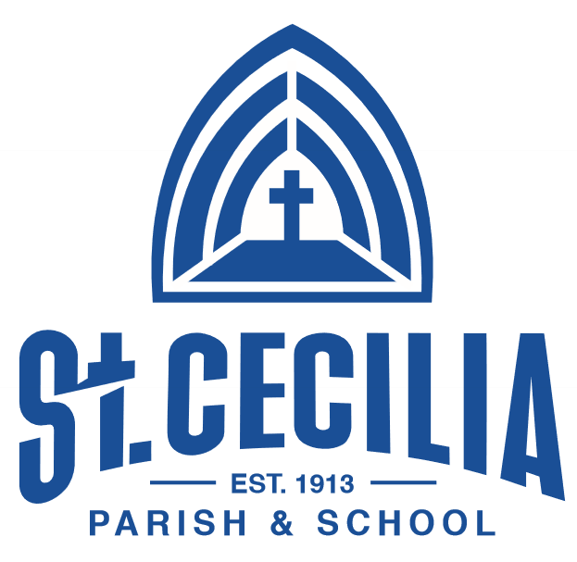

Aug. 31-Sept 4:Faculty &Staff Inservice Week

W/Sept. 2: Ready-for-School Fair (4-7pm)

New Parent Orientation (6:30pm)

SEPTEMBER
8 First Day of School!
17 “Back to School” Night
22 School Picture Day
24 School Advisory Council 6:15pm
23-27 Gr. 8: OMSI Science Camp (John Day)

OCTOBER
9 NO SCHOOL / Arch. Curriculum Inservice
20 Progress Reports (Gr. 1-8)
22-23 NO SCHOOL /***CONFERENCES***

NOVEMBER
9 School Picture Re-Take Day
11 NO SCHOOL /Veterans Day
12 School Advisory Council 6:15pm
25 11:30 Dismissal/Pre-Thanksgiving Holiday
26-27 NO SCHOOL / Thanksgiving Holiday
29 Advent Begins

DECEMBER
4 11:30 Dismissal/PD with Archdiocese
End of 1st Trimester
17 Christmas Program&Concert
18 11:30 Dismissal/Faculty Inservice
21 Christmas VacationBegins

JANUARY
4 School Resumes
11 Registration for 2021-2022 begins
18 NO SCHOOL / MLK, Jr. Day
24 PK-8 OPEN HOUSE (10:00-12:00)
29 Registration Due for current families

Do Small Things with Great Love!

FEBRUARY
3 Progress Reports (Gr. 1-8)
11 School Advisory Council 6:15pm
12 Kindergarten Roundup/New K Registrants
15 NO SCHOOL /Presidents’ Day
16 NO SCHOOL /Arch. Curriculum Inservice
17 Ash Wednesday—Lent Begins

MARCH
1-3 Accreditation Visit on Campus
5 NO SCHOOL/Accreditation Celebration Day!
19 End of 2nd Trimester
22-26 SPRING BREAK

APRIL
5 NO SCHOOL/Easter Monday
8 School Advisory Council 6:15pm
16 11:30 Dismissal/PD with Archdiocese
26 NO SCHOOL/ Optional Spring Conferences

MAY
3-7 Staff Appreciation Week
14 ST. CECILIA JOGATHON!!!
21 Middle School Musical 7:30pm
24-27 Student Council Election Week
31 NO SCHOOL /Memorial Day

JUNE
3 SAC + PA Team Meeting and Social
7 Field Day
10 Spring Music Department Concert 6:30pm
11 Preschool Graduation 9:00am
15 8th Grade Graduation Mass 7:00pm
18 Last Day: K-7 / 11:30 Dismissal
21-23 Teacher Workdays

