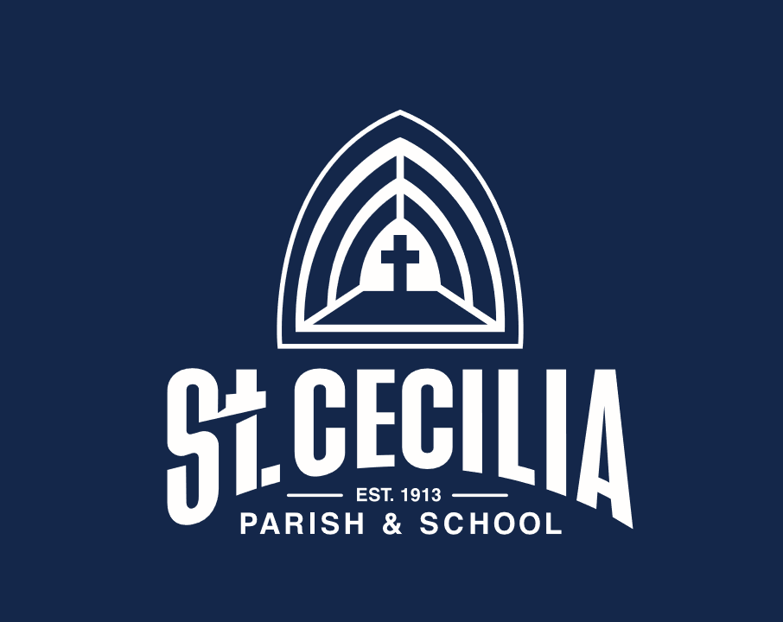

Aug. 30-Sept 3: Faculty &Staff Inservice Week

Wed. Sept. 1: PK-8 Ready-for-School Fair (4-7pm)

New Parent Orientation (7-8pm)

SEPTEMBER
7 First Day of School!
10 Welcome Back BBQ (hopefully!) 5pm-8pm
16 “Back to School” Night 6:30pm
21 School Picture Day
23 School Advisory Council 7pm

OCTOBER
8 NO SCHOOL / Arch. Curriculum Inservice
19 Progress Reports (Gr. 1-8)
21 School Advisory Council 7pm
21-22 NO SCHOOL /***CONFERENCES***

NOVEMBER
8 School Picture Re-Take Day
11 NO SCHOOL /Veterans Day
24 11:30 Dismissal/Pre-Thanksgiving Holiday
25-26 NO SCHOOL / Thanksgiving Holiday
28 Advent Begins

DECEMBER
2 School Advisory Council 7pm
3 11:30 Dismissal/PD with Archdiocese
End of 1st Trimester
16 Christmas Program & Concert
17 11:30 Dismissal/Faculty Inservice
20 Christmas Vacation Begins

JANUARY
3 School Resumes/Registration Begins
10 Registration for next year opens
13 School Advisory Council 7pm
17 NO SCHOOL / MLK, Jr. Day
23 PK-8 OPEN HOUSE (10:00-12:00)
28 Registration Due for current families
31 Progress Reports (Gr. 1-8)

FEBRUARY
4 No School/ Archdiocese Faith Formation
11 Kindergarten Roundup/New K Registrants
21 NO SCHOOL /Presidents’ Day
22 NO SCHOOL /Arch. Curriculum Inservice
24 School Advisory Council 6:15pm

MARCH
2 Ash Wednesday- Lent begins
18 End of 2nd Trimester
21-25 SPRING BREAK

APRIL
7 School Advisory Council 7pm
18 NO SCHOOL/Easter Monday
22 11:30 Dismissal/PD with Archdiocese
29 NO SCHOOL/ Optional Spring Conferences

MAY
2-6 Staff Appreciation Week
13 ST. CECILIA JOGATHON!!!
20 Middle School Musical 7:30pm
23-27 Student Council Election Week
30 NO SCHOOL /Memorial Day

JUNE
2 SAC + PA Team Meeting and Social
6 Field Day
9 Spring Music Department Concert 6:30pm
10 Preschool Graduation 9:00am
14 8th Grade Graduation Mass 7:00pm
17 Last Day: K-7 / 11:30 Dismissal
20-22 Teacher Workdays

